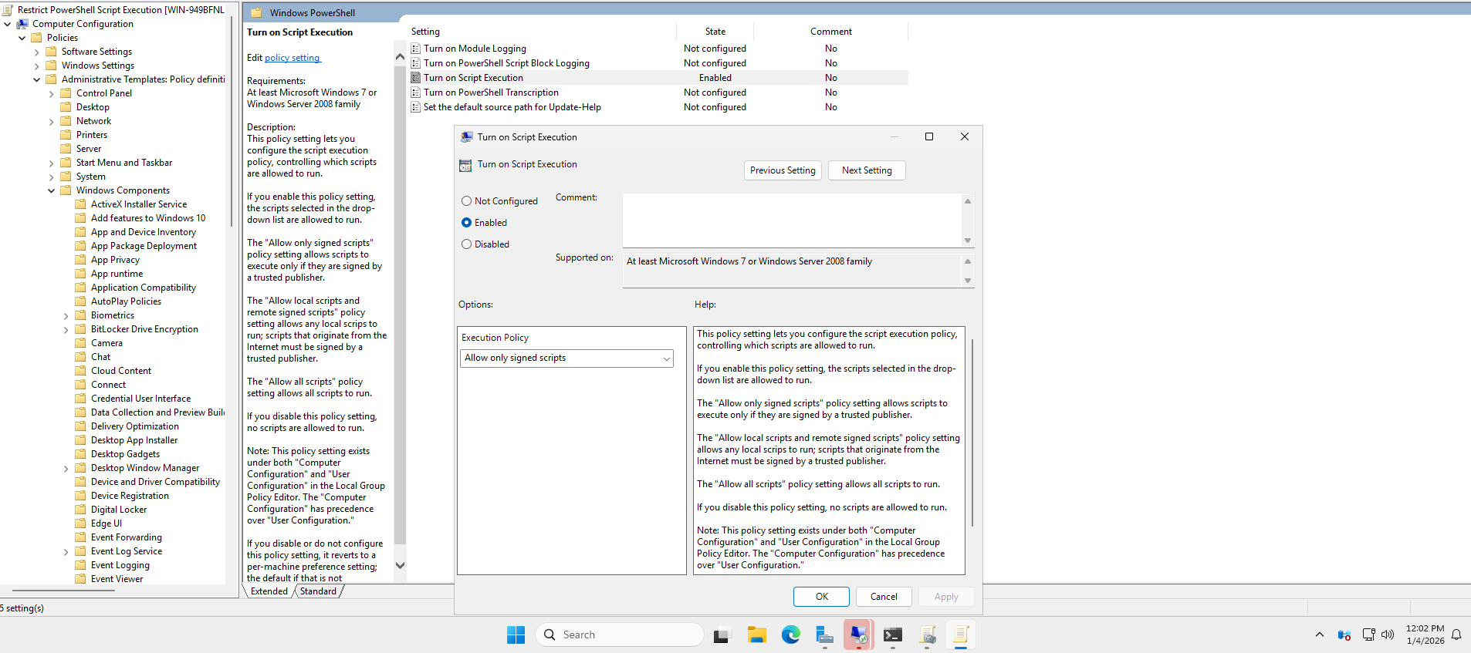
Endpoint Policies and Security in Active Directory
A Group Policy Object (GPO) was created to restrict PowerShell script execution for regular users.
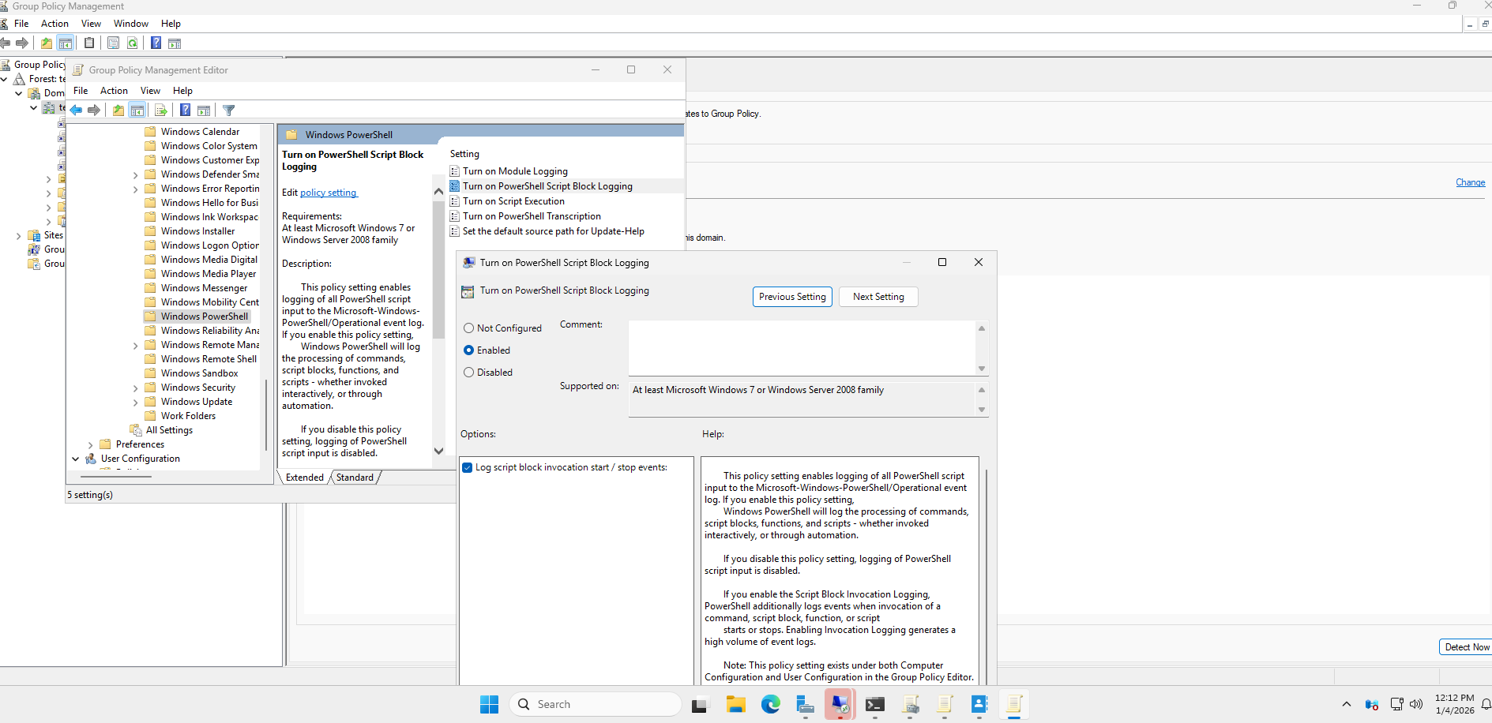
PowerShell Script Logging Configuration
A separate GPO was created to enable PowerShell script logging at the domain level.
PowerShell commands used:
New-GPO -Name "Enable PowerShell Logging" | New-GPLink -Target "DC=testcorp,DC=local"
Set-GPRegistryValue -Name "Enable PowerShell Logging" `
-Key "HKLM\SOFTWARE\Policies\Microsoft\Windows\PowerShell\ScriptBlockLogging" `
-ValueName "EnableScriptBlockLogging" `
-Type DWORD `
-Value 1
Set-GPRegistryValue -Name "Enable PowerShell Logging" `
-Key "HKLM\SOFTWARE\Policies\Microsoft\Windows\PowerShell\ModuleLogging" `
-ValueName "EnableModuleLogging" `
-Type DWORD `
-Value 1
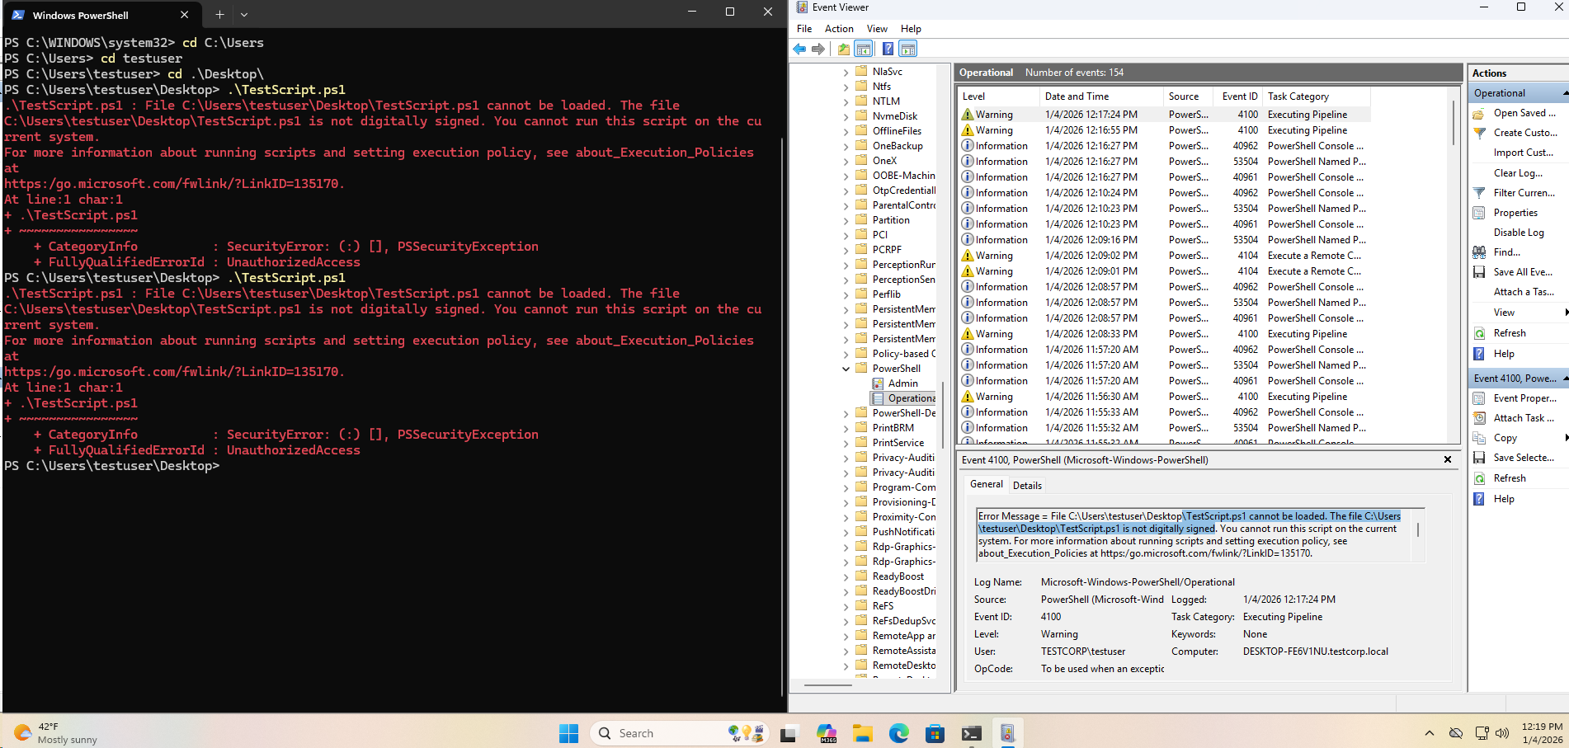
Verification
This configuration confirms that regular users can no longer execute PowerShell scripts. Additionally, PowerShell script execution and attempted execution events are now logged, validating that endpoint security controls are functioning as intended.

